InCubed Activity Web Page (AWP) Template

Please use the template below to prepare your Activity Web Page by replacing all the text in blue with your own. Once completed, save to disk and then send by electronic to the ESA Technical Officer in charge of the activity.

Please note that this template has to be used only for the first submission of the activity web page or for major subsequent redesign.

For the provision of the updates on the Current Status, please use the relevant paragraph in the Monthly Progress Report, and not this template.

Note:
Please include images wherever suitable in JPG/JPEG/PNG format (no transparency) with 100% size and quality in high resolution for use on the web and in print, and state who shall be credited for these images.

If you are not the sole contractor, please co-ordinate your AWP with the sub-contractor(s) and/or activity partner(s). Only the prime contractor is entitled to deliver the AWP to ESA.

Strictly avoid the use of the future tense, e.g. “The product will provide the following features…” or “The following tasks will be carried out…”.
Instead use forms for the text such as “The following tasks are covered in the activity…”, which will remain valid even after the activity has been completed.

Please enter an X as appropriate into the cells of the right hand column.
Select one or more cycles and one or more domain (aligned with your submitted proposal)
SPACE SEGMENT | Platform
SPACE SEGMENT | Payload
GROUND SEGMENT | Ground stations & Mission Management
GROUND SEGMENT | Ground Networks and Data distributions
DATA SEGMENT | Data Processing, Visualization
 | Data Analytics, Insights & Applications
InCubed Cycle | De-risking
InCubed Cycle | Product development

Activity Header Information
Title: | Activity acronym/abbreviation, if applicable.
Full Activity Name: | Full activity name
Activity Logo: | 
Teaser: | Please provide in <60 words a standalone outline of the service/solution. This section will not be part of the online AWP itself. It will appear only on the activities overview pages, next to the activity logo.

High-Level Executive Summary (in common language for general audience)
Objectives of the Product: | Describe in <200 words the objectives of the product i.e. what are the key problems of the customers/users, what is the product/solution you intend to provide and how will you provide it. Avoid the use of phrases like “The objective is to investigate the technical feasibility and economic viability...”

Low-Level Description (detailed)
Customers and their Needs: | Describe in <200 words the targeted customers (and/or users), how they are involved in the activity, or using the product that will be developed. Define the identified users’/customers needs and the challenges trying to meet these needs.
Target customers/users countries | Please indicate the country/countries of the targeted customer/users
Product description: | Describe in <200 words product that you are developing and/or any part of the end-to-end system, its capabilities and the performances. Describe the innovation aspects that you are focusing on. Provide (when possible) a description of how the customer (and/or users) will interact with the product.  Show the product/system architecture (on a high level), highlighting the main system building blocks (on a high level).  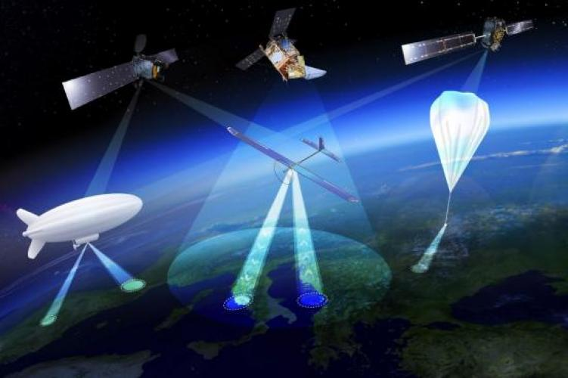  (The image above is an example.)

Added Value: | Describe in <200 words why the proposed solution is bringing added value as opposed to other methods from potential existing competitors.  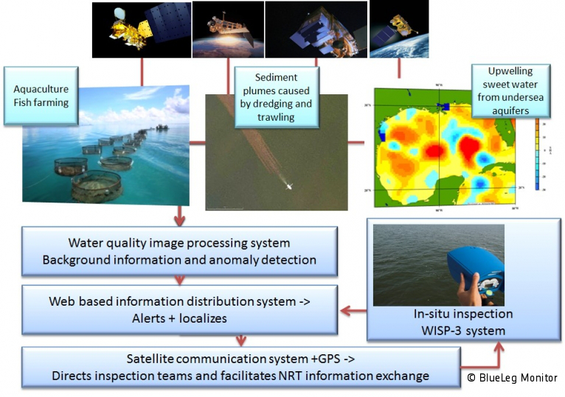(The image above is an example.)

Activity Details
Current Status: | Describe in <150 words the status of the activity (brief summary of achievements, work currently in progress, activities about to start, activity has been completed)

Activity Team
Prime Contractor Company: | Name | Country | URL |   Company Logo
Subcontractor A: | Name | Country | URL |   Company Logo
Subcontractor B: | Name | Country | URL |   Company Logo
Contractor Project Manager: | Name |  | Email
Contractor Project Manager: | Postal Address |  | Company
Contractor Project Manager: | Phone
ESA Technical Officer: | Name |  | Email

Related Content
Related links: | Please enter below any links related to this activity, i.e. links to web pages outside the InCubed portal, links from other ESA activities. Please provide a short title for the hyperlink.
Related links: | Title | URL
Related links: | Title | URL
Related links: | Title | URL
Related links: | Title | URL
Related Documents: | Please list here the related documents such as the Final Report or further readings to be published for registered users on the portal.

